1. 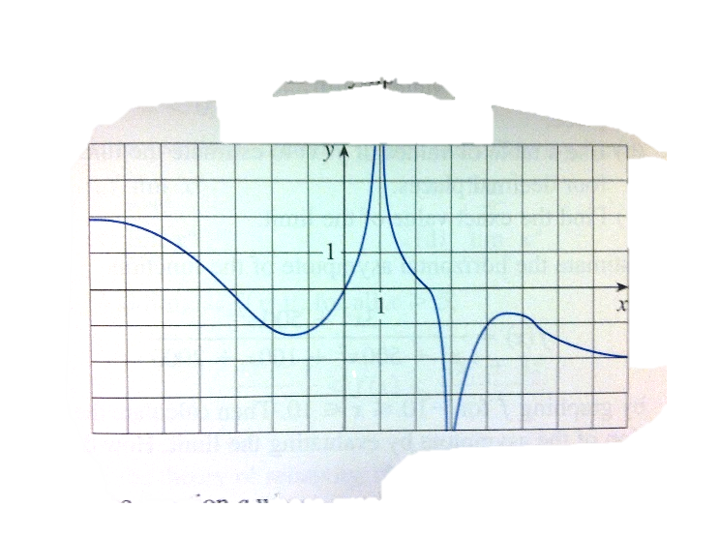Use Graph 1 to find the next limits.

Graph 1

$\lim_{x→∞}{f\left(x\right)}$

As $x$ increases without end, $y$ becomes $-2$.



$\lim_{x→-∞}{f\left(x\right)}$

As $x$ increases without end, $y$ becomes $2$.

$\lim_{x→1}{f\left(x\right)}$

As $x$ approaches $1$, $y$ increases without limit.

$\lim_{x→3}{f\left(x\right)}$

As $x$ approaches 3, $y$ decreases without limit.

* 1. The equations of the asymptotes

$$x=1$$

$$x=3$$

|  |  |
| --- | --- |
| $$x$$ | $$\frac{x^{2}}{2^{x}}$$ |
| 0 | **0** |
| 1 | **0.5** |
| 2 | **1** |
| 3 | **1.125** |
| 4 | **1** |
| 5 | **0.78125** |
| 6 | **0.5625** |
| 7 | **0.382813** |
| 8 | **0.25** |
| 9 | **0.158203** |
| 10 | **0.097656** |
| 20 | **0.000381** |
| 50 | **2.22E-12** |
| 100 | **7.89E-27** |

1. 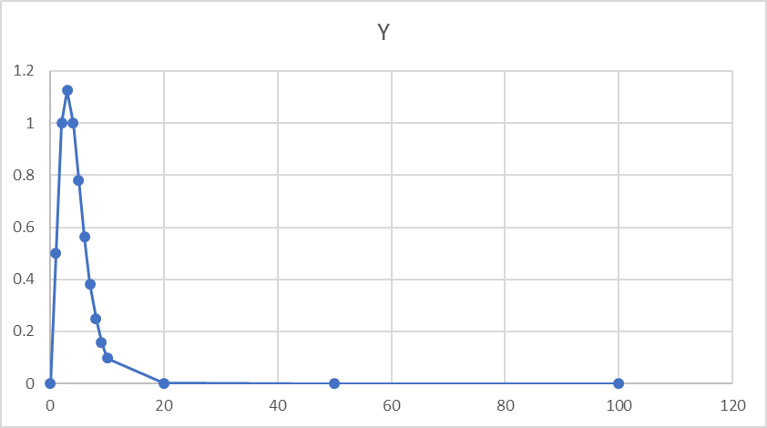Find the value of $\lim_{x→∞}{\frac{x^{2}}{2^{x}}}$ by evaluating the function by plugging 0, 1, 2, 3, 4, 5, 6, 7, 8, 9, 10, 20, 50, and 100 into $x$. Then use a graph to support your answer. See the table to the right and Graph 2.

Graph 2

$\lim_{x→∞}{\frac{x^{2}}{2^{x}}}=0$.

1. 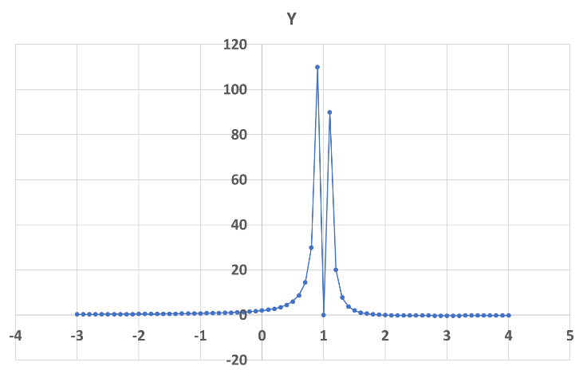Find $\lim_{x→1}{\frac{2-x}{{\left(x-1\right)}^{2}}}$.

Graph 3

Looking at Graph 3, as $x$ approaches $1$, it appears that $y$ increases to infinity.

$$\lim_{x→1}{\frac{2-x}{{\left(x-1\right)}^{2}}}=∞$$

1. Find $\lim_{x→∞}\left(\sqrt{9x^{2}+x}-3x\right)$.

$$\backslash lim\backslash below\{x\backslash rightarrow∞\}\{$$